If there a cup is 236 mL, a pint is two cups, a quart is two pints, and a gallon is 4 quarts, how many milliliters (mL) are in a gallon.
14.75
118
944
1888
3776

Flag this Question
Question 4
On average 1500 kg (about 500 gallons) of gasoline are used per car per year in the US. (How do you compare?) How much energy (in kJ) is produced by the combustion of that much gasoline? Look in your book or notes for the energy density of gasoline (octane).
Less than 35,000,000
35,000,000 to 45,000,000
45,000,000 to 55,000,000
55,000,000 to 65,000,000
65,000,000 to 75,000,000
More than 75,000,000

Flag this Question
Question 5
The density of vegetable oil is 0.92 g/mL. There are 3.8 L in a gallon. There are 2.2 pounds (lb) in a kilogram (kg). How much in pounds does a gallon of vegetable oil weigh? Some people by vegetable oil by the gallon.
Less than 7.5
7.5 to 7.6
7.6 to 7.7
7.7 to 7.8
More than 7.8

Flag this Question
Question 6
A kilowatt-hour (kWh) is a unit of energy because it is a unit of power (kW) multiplied by a unit of time. A Watt (W) is a Joule/second (J/s). There are 60 seconds in a minute, 60 minutes in an hour, and 24 hours in a day. How many kWh are produced by a 280 MW power plant in one day. kilo (k) is 1000. Mega (M) is 1,000,000. (Note: You may not have to use all the conversion factors provided. An average household uses 30-40 kWh per day.)
Less than 1,000,000
Between 1,000,000 and 5,000,000
Between 5,000,000 and 7,000,000
Between 7,000,000 and 9,000,000
More than 9,000,000

Flag this Question
Question 7
If all 7.4 billion people in the world used as much energy per person as in the United States (pop. 325 million), how many EJ would we need? (Round off US energy use to 100 EJ total)
500-1000 EJ
1000-1500 EJ
1500-2000 EJ
2000-2500 EJ
More than 2500 EJ

Flag this Question
Question 8
What is the approximate ratio of US per person energy use to worldwide per energy person use?
1:1 - Individuals in the USA use about as much as individuals worldwide.
2:1 Individuals in the USA use twice as much as the world average.
1:2 - Individuals in the USA use half as much as the world average.
4:1 - Individuals in the USA use four times as much as the world average.
10:1 - Individuals in the USA use ten times as much as the world average.

Flag this Question
Question 9
If the population of the world is 7.4 billion and each person needs 2500 kilocalories to live per day, how many EJ does it take to feed the world in a year? (1 kilocalorie = 4.184 kilojoules)
27.87

Flag this Question
Question 10
How much heat (in kJ) would be released if 1 metric tonne (1000 kg) of sub-bituminous coal undergoes complete combustion? The energy density for sub-bituminous coal is 24 kJ/g.

41.7
24,000
42,000
24,000,000

Flag this Question
Question 11
If coal combustion follows the following unbalanced chemical equation how many CO2 molecules are formed for every SO2 molecule formed (start by balancing the equation)

C135H96O9NS + O2 -> CO2 + H2O + NO2 + SO2
one CO2 per SO2
135 CO2 per SO2
67 1/2 CO2 per SO2
two CO2 per SO2

Flag this Question
Question 12
If coal combustion follows the following unbalanced chemical equation how many O2 molecules are consumed for every CO2 molecule formed (start by balancing the equation)

C135H96O9NS + O2 -> CO2 + H2O + NO2 + SO2
313 O2 per 270 CO2
two O2 per CO2
156 1/2 O2 per 135 CO2
67 1/2 O2 per CO2

Flag this Question
Question 13
If coal combustion follows the following unbalanced chemical equation how many H2O molecules are formed for every CO2 molecule formed (start by balancing the equation)

C135H96O9NS + O2 -> CO2 + H2O + NO2 + SO2
one H2O per CO2
two H2O per CO2
48 H2O per 135 CO2
67 1/2 H2O per CO2

Flag this Question
Question 14
What type of reaction is shown in the unbalanced equation below?
C2H4(g) + O2(g) → CO(g) + H2O(g)

Hydrolysis
Complete combustion
Condensation
Incomplete combustion

Flag this Question
Question 15
In carbon monoxide (CO) what is the bond between the carbon and the oxygen in the correctly written Lewis structure? You have to count electrons and make sure each element has a full outer shell.
A CO single bond
A CO double bond
A CO triple bond
No answer text provided.

Flag this Question
Question 16
Use the bond energies in table 4.2 to calculate the energy changes associated with the following reaction. Make sure to use the information from the previous question.
2 H2 (g) + CO (g) → CH3OH (g)
Change in energy = kJ/mol

Is this reaction endothermic or exothermic?
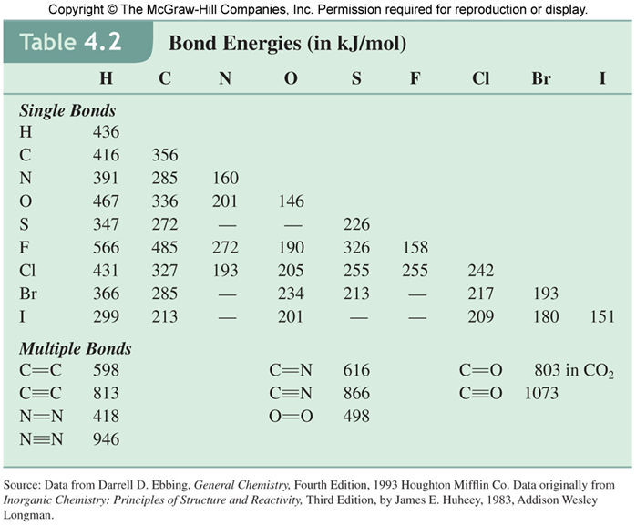

Flag this Question
Question 17
Use the bond energies in table 4.2 to calculate the energy changes associated with the following reaction:
H2 (g) + O2 (g) → H2O2 (g)
Change in energy = kJ/mol

Is this reaction endothermic or exothermic?

Flag this Question
Question 18
Use the bond energies in table 4.2 to calculate the energy changes associated with the following reaction:
2 BrCl (g) → Br2 (g) + Cl2 (g)
Change in energy = kJ/mol

Is this reaction endothermic or exothermic?

Flag this Question
Question 19
One way to produce ethanol for use as a gasoline additive is the reaction of water vapor with ethylene:
CH2=CH2 (g) + H2O (g) → CH3CH2OH (l)
Is this reaction endothermic or exothermic?

Flag this Question
Question 20
What is the product (a pollutant) involving sulfur when a fuel source like coal contains sulfur is combusted? (The formula we will use for coal is C135H96O9NS.)
S8
H2S
SO2
H2SO4
SO42–

Flag this Question
Question 21
Using a common experience as a measure, what is comparable to 2 GJ?
Burning a log of wood
Eating a Snickers bar
Burning a tank of gasoline
The amount of energy a typical American uses in one year
The energy used by a city in the developed world

Flag this Question
Question 22
How much energy is used by the whole world?
550 kJ
550 MJ
550 GJ
550 TJ
550 EJ

